Jade Pearl
COSC 320-001 Lab 03: Binary Tree 2/22/2023

Lab report: I have finished all the tasks of the lab with collaboration from Stephora, a classmate, when I was stuck in the second exercise of the lab. It took me approximately 4 hours to complete.

Pre-lab:
- Review information about trees and Binary trees
  - Read lecture notes
- Read and understand given file d_tnode.h
- Read the given header file d_tnodel.h and understand its functions buildTree, depth, deleteTree, clearTree, countLeaf

Files Created:
countOneChild.h, Lab03_01.cpp, max.h, Lab03_02.cpp

Lab 3.1
Exercise 1: Count one child nodes in a tree:
Source Code:
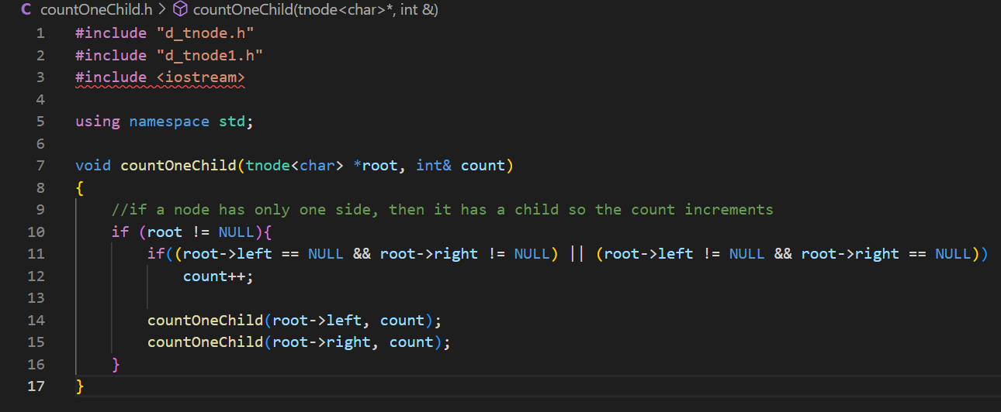
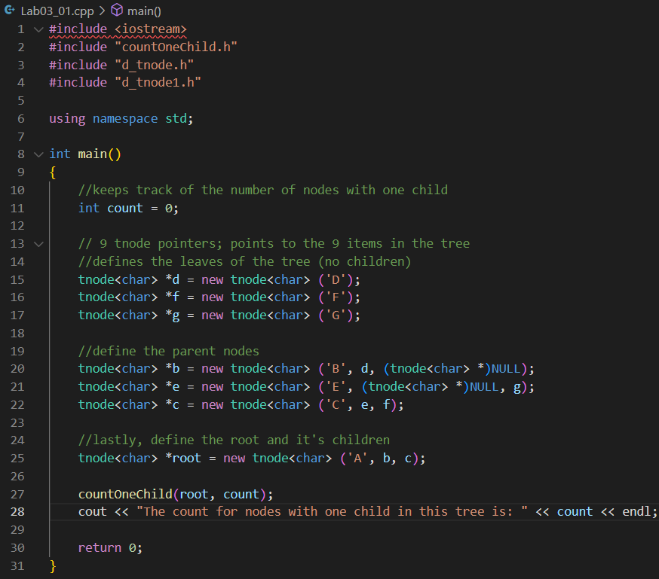

Sample Output:

There is only one tree used for this lab so there is only one sample output.
NO questions for this lab

Exercise 2: find a maximum value in a binary tree
Source Code:
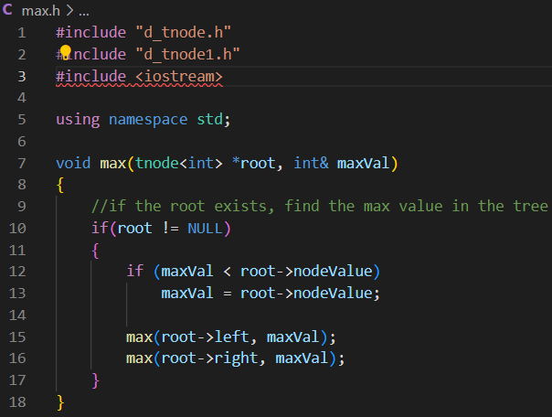
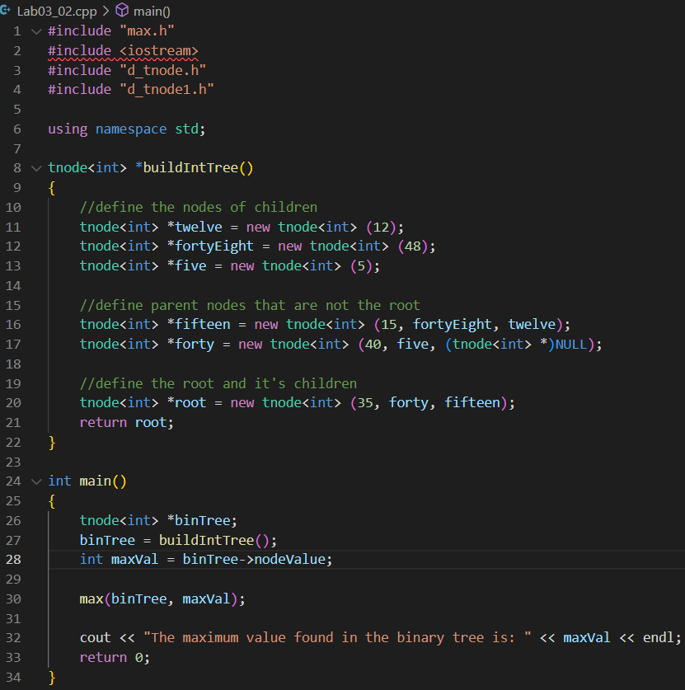
Sample Output:
There is only one tree used for this lab, so the sample output is the same each run.
NO questions for this lab

